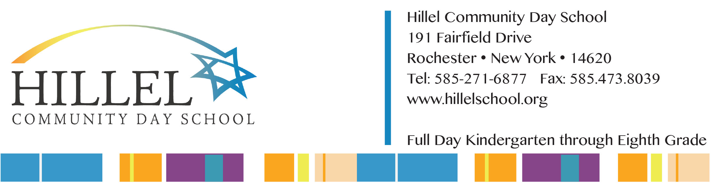
For Office Use Only:

DATE RECEIVED: __________ REGISTRATION FEE: _________
STUDENT I.D. ___________________
REFERRED BY: ______________________________________

New Student Admission Application

Grade: ____ in Academic Year 20 ___

PERSONAL INFORMATION

Applicant’s Legal Name: ____________________________________________________________ Male Female
first middle last

Preferred First Name: ___________________ Hebrew Name: __________________ Birth date: ____/____/____ Age: _____
(if known)
Birthplace: ____________________________________________________________________________________________
CITY STATE COUNTRY

Language(s) spoken at home: _______________________________________________________________________________

Spoken Hebrew: None Some Fluent Written Hebrew: None Some Fluent

Other Languages Studied / How Many Years? _____________________________________________________________________

Address: _____________________________________________________________________ Home Phone: ( ) ___________
STREET ADDRESS CITY STATE ZIP

Home School District: _________________________________

Current School: __________________________________________________________ Current Grade: ____________

Previous School Attended: _________________________________________________________ Dates: ____________________

Previous School Attended: _________________________________________________________ Dates: ____________________

Has applicant ever applied to Hillel? Yes No If yes, when? ___________

Has a sibling previously attended Hillel Community Day School? Yes No If yes, name/current grade: __________________

Synagogue Affiliation, if any (Optional): ___________________________________________________________________________________

parent/guadian information (please mark all that apply):

Married Divorced Separated Single Parent Household Father Deceased Mother Deceased
Father Has Custody Mother Has Custody Joint Custody Student Lives With Step-Parent
Other _________________

Did you indicate above that you and your spouse are separated/divorced? Yes No
If parents are separated/divorced, you must attach a current copy of the custody agreement.

PARENT/GUARDIAN INFORMATION

parent/guardian #1 Best way to contact: Home Cell Work E-mail

Title: _______ Name: __________________________________________________________________________________
(Dr. /Mr. /Ms./ Mrs.) First Last

Address: _______________________________________________________________________________________________
STREET ADDRESS CITY STATE ZIP

______________________ _______________ _________________ ________________________________
home phone Cell phone Work Phone Preferred E-mail address

Schools/Colleges attended: _________________________________________________________________________________

Occupation & Company:____________________________________________________________________________________ (If student, please list school name)

parent/guardian #2 Best way to contact: Home Cell Work E-mail

Title: _______ Name: __________________________________________________________________________________
(Dr. /Mr. /Ms./ Mrs.) First Last

Address: _______________________________________________________________________________________________
STREET ADDRESS CITY STATE ZIP

______________________ _______________ _________________ ________________________________
home phone Cell phone Work Phone Preferred E-mail address

Schools/Colleges attended: __________________________________________________________________________________

Occupation & Company: ____________________________________________________________________________________ (If student, please list school name)

other parent/guardian Best way to contact: Home Cell Work E-mail

Title: _______ Name: __________________________________________________________________________________
(Dr. /Mr. /Ms./ Mrs.) First Last

Address: _______________________________________________________________________________________________
STREET ADDRESS CITY STATE ZIP

______________________ _______________ _________________ ________________________________
home phone Cell phone Work Phone Preferred E-mail address

Schools/Colleges attended: __________________________________________________________________________________

Occupation & Company:____________________________________________________________________________________ (If student, please list school name)

ADDITIONAL FAMILY INFORMATION

Student lives with: Both parents Parent/Guardian 1 Parent/Guardian 2 Other______________________________

other children in the family:

Sibling Name Birth Date & Year Current School/Daycare

1. ___________________________ _________________ __________________________________

2. ___________________________ _________________ __________________________________

3. ___________________________ _________________ __________________________________

4. ___________________________ _________________ __________________________________

Other family members who attended Hillel Community Day School: (Please list name, relationship to student and years attended)

GRANDPARENT INFORMATION:
Paternal Grandparents: Maternal Grandparents:

Name: _____________________________________________ Name: ____________________________________________________

Address: ____________________________________________ Address: ___________________________________________________

____________________________________________________ __________________________________________________________

student’s educational needs

Does your child have an Individualized Educational Plan (“IEP”)? No Yes--If yes, please attach full documentation
Some schools write a 504 plan. Does your child have a 504 Plan? No Yes
Has your child received any type of assistance or counseling outside of the classroom? No Yes
If yes, please indicate the nature of any special needs or learning challenges: ________________________________________
______________________________________________________________________________________________________
Are there any medical facts that we should know about that will help us meet your child’s needs (such as chronic health issues, physical accommodations, treatment for emotional concerns)? If yes, please indicate how you and the student’s current school have provided support:_______________________________________________________________________

Please select your Tuition preference below and once your application is approved, we can create your tuition agreement (See Tuition Schedule Document Enclosed).

Standard Tuition Tiered Tuition Financial aid through PSAS

Please select your Bingo preference (See Tuition Schedule for Bingo details).

No Bingo “Opt-in” One monthly shift “Opt-in” Two monthly shifts

I/We understand that the withholding of information or incorrect information may disqualify the applicant for admission or may be used later for the applicant’s withdrawal and forfeiting of fees.

Parent/Guardian: ______________________________ _____________________________________Date: ____________
Print signature

Parent/Guardian: ______________________________ _____________________________________ Date: ____________
Print signature

Please include a $300.00 deposit, and indicate method of payment below. Checks should be made payable to “Hillel Community Day School”. This deposit is applicable to tuition.
Method of Payment: Check CC Type & #: _____________________________ Exp:_________ CCV: ________

PLEASE SHARE WITH US

How did you learn about Hillel Community Day School? (Please mark all that apply and specify publication, media channel or event)

Current Parents Past Parents Current Student(s) Past Student(s) Friends/Relatives Website
Yellow Pages Television/News: _____________ Newspaper Article: ___________ Magazine Ad: _________
Attended Event: _________________

Key factors influencing your application to Hillel Community Day School: (Please mark all that apply)

Dedication to Judaism Hebrew Language Differentiated Learning Faculty Uniquely Integrated Curriculum
Close-Knit Community Music & Arts Program Math & Science program Reputation Class Size & Individual Attention
Facilities Safety

Do you or the applicant know anyone (parents, students or faculty members) who is part of our Hillel Community Day School family?
_______________________________, _______________________________, ___________________________

